EXCAVATION OF THE SHIPWRECK
CLARENCE: Port Phillip Bay,
October 1987

Peter Harvey,
Maritime Archaeological Unit
11-1-1989

Not to quoted without the permission of the author

ACKNOWLEDGEMENTS.

The completion of the third phase of the Clarence project has been the result of cooperation and generosity on the part of a number of individuals and organizations. It is with pleasure that I acknowledge and thank them for their contributions.

Funding for the work was provided by the Australian Heritage Commission through the National Estate Grants Scheme. Additional financial logistical assistance was provided by the Victorian Ministry for Planning and Environment through the Victoria Archaeological Survey (VAS).

Thanks also to Dotmar Products, Mike Ryan of McNeal Plastics and Eric Turner of Cadillac Plastics for providing, free of charge, acrylic sheet used during the fieldwork.

For their support during the project I wish to thank the staff of the VAS, particularly, Shirley Strachan, Nic Clark, Margaret Baron and the late Rosemary Buchan.

Assistance before and during the fieldwork was provided by the following members of the Maritime Archaeology Association of Victoria: David Carrol, Terry Arnott, Lyall Mills, Cate Leslie, Wayne Caldow, Eric Langenberg, Gary Smith, Chris Gaskill and Meredith Hewitt. Thanks also to Mike Nash, Sue Effenberger, David Nutley, Paul Morris and Ben Wrigley for their help during the excavation.

My special thanks go to Mick Jackiw, Brad Duncan and Kieran Hosty who together formed a dedicated and reliable nucleus for the field team. Special thanks also to Leonie Foster who took on the unenviable task of checking the drafts of this report, and to Geoff Hewitt for his expert assistance in producing the site plan and artifact drawings. My thanks also to Jugo Ilic of the CSIRO Division of Forestry and Forest Products for doing his best to identify yet another smelly bag of waterlogged Eucalyptus wood.

Finally I wish to thank the Victorian Historic Shipwrecks Advisory Committee for their support of the project.

CONTENTS

1.0 INTRODUCTION 1

2.0 AIMS 3
2.1 Construction and Hull Morphology 3
2.2 Fasteners and Fittings 5
2.3 Internal Structure 6
2.4 Sediment Monitoring 6

3.0 METHODS 6
3.1 Excavation 7
3.1.1 Trench No 1 (Bow) 7
3.1.2 Trench No 2 (Midships) 7
3.1.3 Trench No 3 (Stern) 7
3.2 Backfilling 9
3.3 Profiling and Probing 9
3.4 Artefacts 10
3.4.1 Conservation of artefacts 12
3.5 Recording 12

4.0 RESULTS AND DISCUSSION 12
4.1 Probing and Profiling 12
4.2 Excavation 15
4.3 Construction and Fastening 16
4.3.1 Knees 19
4.3.2 Internal structure 20
4.3.3 Anti-fouling 22
4.3.4 Fasteners 22
4.3.5 Timber samples 23
4.4 Artefacts 23
4.5 Analysis of artefacts and samples 25
4.6 Conclusions 25

5.0 FUTURE MANAGEMENT AND RESEARCH 27
5.1 Management 27
5.1.1 Site security 27
5.1.2 Sand level monitoring 28
5.1.3 Artefact monitoring 29
5.1.4 Air probing 29
5.1.5 Public access and interpretation 29
5.2 Research 30
5.2.1 Sampling 30
5.2.2 Shoddy construction - the exception or the rule? 30

6.0 RECOMMENDATIONS 31
6.1 Management recommendations 31
6.2 Research recommendations 32

7.0 REFERENCES 33

APPENDIXES
1 SAND PROFILING. Raw data from 1985 and
1987 field seasons. 35

2 ANALYSIS OF ARTEFACTS 44

3 CATALOGUE OF ARTEFACTS RAISED DURING THE
EXCAVATION OF THE CLARENCE. 48

LIST OF FIGURES
1 Positions of trenches on the site 8
2 Guidelines for raising artefacts 11
3a 1985 Sand surface 14
3b 1987 Sand surface 14
4 Site plan 17
5 Comparison of scantlings measured
from the Clarence 18

1

1.0 INTRODUCTION
The wooden schooner Clarence was launched on the Williams River in northern New South Wales in 1841. It was a relatively small vessel, (67 tons register) with a length of only 50 feet. The Clarence was employed in carrying a variety of cargoes for the inter-colonial trade. At different stages during its career the vessel was modified for carrying such cargoes as livestock, timber and occasionally passengers. In September 1850, after a relatively brief career the Clarence ran aground on the east bank of the Coles Channel in Port Phillip and became a total wreck. Its cargo of sheep was saved. The wreck remained visible for some time, but it eventually subsided and was forgotten. Further detailed technical and historical information can be found in Gesner (1984).

Almost 130 years later the wreck of the Clarence was re-discovered by members of the Maritime Archaeology Association of Victoria (MAAV) who reported the find to the Maritime Archaeological Unit (MAU) of the Victoria Archaeological Survey (VAS). Subsequent research by the MAU indicated that the site was the earliest and best-preserved example of an Australian-built trading vessel yet located in Victoria. This research also indicated that, in view of the substantial number of Australian-built vessels wrecked in its waters, Victoria was well placed to undertake a programme of research into early Australian shipbuilding.

2

Investigation of the Clarence site was suggested as the starting point for a study of the wrecks of Australian-built vessels.

The Clarence project was planned as a multi-phase project with the following overall aims: (1) to determine the extent of historical and archaeological evidence associated with the site; (2) to identify and define areas for more detailed research; (3) to formulate a management programme for the site, using information gained from the historical and field investigations.

In order to progress systematically the project was divided into four separate phases. Only a brief description of the early phase is necessary here. A complete description of all the phases of the project can be found in Harvey (1986). Phase one of the project involved documentary research aimed at reviewing the available historical records relevant to both the Clarence and to Australian shipbuilding in general. It was designed to illuminate areas where future archaeological research could be most fruitful.

Phase two of the project was a pre-disturbance survey designed to assess the archaeological potential of the site. The information gained from the pre-disturbance survey, in conjunction with that collected during phase one, was to provide a bases for the formulation of a research design for any future work undertaken on the site.

3

Phase three, the current phase, was planned as an excavation aimed at answering specific questions generated during the course of, and as a result of, work in phases one and two.

The fourth and final phase of the project was envisaged as the development of an on-going management plan for the site.

This report provides a description of work undertaken as phase three of the project (excavation) and presents a discussion of the results obtained.

2.0 AIMS
Results of the first two phases of the Clarence project suggested that investigation of the wreck had the potential to provide information that could make a significant contribution to the understanding of the development of early Australian shipbuilding. The particular aspects of this theme best served by excavation of the site are construction and fastening methods, hull design, and fitting out of the vessel’s interior for operation in specific trades. Consequently, the aims of the excavation were as follows:

2.1 Construction and hull morphology.
To record details of the vessel’s construction and hull morphology, in the areas exposed during excavation, with a view to comparing them with construction details available for British-built vessels of similar age, size and function.

4

Gesner (1984) suggests that typically Australian vessels evolved gradually (under the influence of such factors as the environments and trade in which they plied) from traditional British designs which had, in at least one case, been found to be ‘good for nothing’ under Australian conditions (Historical Records of Australia 1819, in Gesner 1984). Australian-built vessels comprise approximately 30 per cent of Victoria’s wreck resource. Continuing investigation of these wrecks has the potential to yield information that will complement the hitherto poorly documented area of Australian shipbuilding activity. Excavation of the site should provide evidence which will help to either prove or disprove the hypothesis that Australian ships evolved from traditional British designs to a form that was well adapted for Australian conditions.

During the pre-disturbance survey (Harvey 1986) a deck beam, not supported by hanging or lodging knees, was discovered. An examination of plans of comparable British vessels suggested that, because the Clarence was not fitted with hanging or lodging knees, it did not conform entirely to British shipbuilding customs. Therefore, as a corollary of the above aim, it was planned that the excavation be used to determine whether or not the vessel was deliberately built without hanging or lodging knees for the deck beams.

5

2.2 Fasteners and fittings.
To raise a sample of fasteners and fittings from the wreck for metallographic analysis. This analysis was to determine, if possible, the origin of the raw material used, the method of manufacture, and the type and quality of the raw material used in the manufacture of these items. The objects of this analyses was to obtain data which would help to answer the question posed by Gesner (1984): ‘did supply problems [of fasteners and fittings] lead to makeshift solutions in the manufacture of items as fundamental and vital as an iron bolt or gudgeon?’ Gesner points out that shortages of such necessities for shipbuilding as bolts, rudder-straps, mast-straps, anchors and chain are assumed to have existed (Hainsworth 1971). He also indicates that the large incidence of shipping losses, especially among Australian-built vessels is partially attributed, by Jeans (1974), to shortages in supply which, in turn, led to lack of sound workmanship and durability in construction.

It was considered likely that analysis of fittings and fasteners from the Clarence might yield information pertinent to the above issues. If so, it might be possible to either confirm or negate the assumptions made by Jeans (1974) and Hainsworth (1971). In either event, the body of knowledge relating to this facet of early Australian shipbuilding would be increased.

6

2.3 Internal structure.
To examine the internal spaces of the vessel for any structural features which suggest alterations made to accommodate specific cargoes, such as sheep, timber, passengers etc. Investigation of internal structures of the hull might well yield evidence of how the vessel was built and/or modified for carrying specific cargoes. This evidence would illuminate another poorly documented area of Australian shipping.

2.4 Sediment monitoring.
To continue the monitoring of sediment movement on the site, in the same manner as the work undertaken on this subject during the pre-disturbance survey. Few studies have been undertaken on how the disturbance of wreck-sites affects their stability. A study of sediment movement on the site would increase understanding of its stability and the implications for the site’s future preservation. Consequently the information gained would have an important bearing on future management decisions.

3.0 METHODS
The methods adopted during the fieldwork were chosen to best fulfill the aims of recording hull construction details, obtaining samples of fasteners, recording internal structure and monitoring sediment movement (section 2.0) and, at the same time, avoiding unnecessary disturbance of the site. This entailed profiling in the proposed trench areas,

7

limited excavation, probing in the areas where excavation was not planned, recording, backfilling, and the raising of artefacts relevant to the research design.

3.1 Excavation.
During this phase of the project it was planned to excavate three trenches, with a total combined area not exceeding 19 square metres. This is approximately 12 percent of the total area of the site. The positions of the trenches on the site are illustrated in Figure 1. The information that each of the trenches was expected to provide is outlined below.
3.1.1 Trench No 1 (Bow)
Internal construction and design details including fastening methods, a transverse section through the hull and details of the bulkhead discovered in this position during the pre-disturbance survey.

3.1.2 Trench No 2 (Midships)
A transverse section through the broadest part of the hull, internal construction details, and an indication of the presence of any obstructions the hull which would distort the hull profiles obtained by probing.

3.1.3 Trench No 3 (Stern)
A transverse section of the stern and identification of a number of structures in this area which were noted during the pre-disturbance survey. Compared to Trenches 1 and 2, this area of the site is the least
9

Intact, consequently, a larger area would need to be excavated in order to gain a better understanding of the interrelationship of the various parts of the vessel exposed in this area. Because of the relatively fragmented nature of the remains in this area it appeared likely that loose fasteners would be abundant there than in the other trenches.
3.2 Backfilling.
At the completion of excavation all trenches were backfilled using sediment from the spoil heaps. Large fronds of seaweed were partially buried in the surface of the newly backfilled areas. This had the effect of reducing the velocity of the current at the sea-bed. As a consequence, the rate of deposition was increased and the backfill protected until it consolidated.

3.3 Probing and Profiling
The site datum level which was established during the pre-disturbance survey (see Harvey 1986), was transferred to a row of wooden stakes driven into the sand at two metre intervals along the west side of the site (see Figure 1). These stakes were used as starting points for profiling and probing transects of the site.
Sub-surface information was obtained by the use of a two-metre hollow aluminium probe to which was attaches a fiberglass tape measure. To ease the probe through compacted sediment, compressed air was passed down the hollow centre of the probe and through a fine nozzle at the tip.
10

Profiling was conducted as described in Harvey (1986) except that on this occasion the leveling transects were recorded at every metre instead of every two metres. The maximum distance between sampling points was 50 centimetres.
Data recorded at each sampling point included the distance of the sand surface below the site datum and, where applicable, the distance below the sand surface of any wreck structure.

3.4 Artefacts.
Prior to the start of the fieldwork a set of guidelines, for raising artefacts during the excavation, was prepared. These are presented, as a flow-chart, in Figure 2. The aims of the flow chart were as follows:
- To ensure that only artefacts directly relevant to the aims of the excavation were to be raised.
- To avoid overloading the limited available conservation facilities.
- To ensure the safety from theft or looting of any intrinsically valuable or rare artefacts.
- To ensure that the maximum information possible was obtained from the material which was raised.
To leave some artefacts on the site rather than raise them all, was a conscious decision. This of course, did not reduce the responsibility of the excavator for the future preservation of the artefacts. During the development of the project it was acknowledged that a programme for monitoring

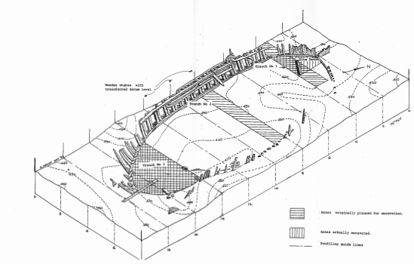

Figure 1

Positions of trenches on the site.

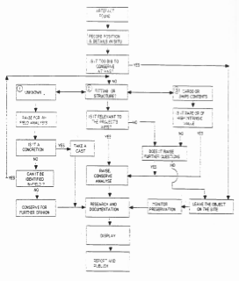

Figure 2

Guidelines for raising.

12

the stability of the artefacts would be needed as part of the management programme for the site.
3.4.1 Conservation of artefacts.
In-field conservation of material raised from the site was undertaken as required by the VAS conservator. Conservation needs were relatively small as the work was concerned mainly with recording hull details in situ.

3.4 Recording.
The large amount of current-borne seaweed encountered on the site made impracticable the construction of a rigid grid system. Most position recording of features on the site was by means of triangulation from the main reference points established during the pre-disturbance survey. Additional reference points were established, when necessary, to improve accuracy. Measurement of site features was supplemented by photography and scale drawings.
All artefacts uncovered during the excavation were recorded in situ. All artefacts recovered were catalogued, and photographed.

4.0 RESULTS AND DISCUSSION
4.1 Probing and Profiling
Probing was originally intended to obtain profiles of the hull in the areas of the wreck which were not to be excavated. These were then to be used to complement the profiles of the hull obtained from the excavated trenches and thus help to build up a body of data from which the shape of the vessel could be determined. However, this aim
13

was thwarted by the large amount of structure within the hull. This prevented clear profiles of the internal surfaces of the vessel from being obtained. The result was that, because of the constraints outlined above, it was impossible to record the internal shape of the hull and thus generate a set of ‘lines’ for the vessel. Thus the probing merely revealed the inaccuracy of the assumption, made after the pre-disturbance survey, that the hull of the wreck would be free from internal structure.
The views of the sand surface presented in Figure 3 were generated from the data collected during the pre-disturbance survey in 1985 (Figure 3a) and prior to the excavation in 1987 (Figure 3b) The raw data from both leveling exercises is presented in Appendix 1. The more uneven surface represented by Figure 3b can be explained by the close space of the points at which leveling data was gathered. The 1985 levelling was carried out on transects spaces at two-metre intervals along the site, whereas the spacing was reduced to one metre for the 1987 exercise.

The plots of the sand levels over the site reinforce the hypothesis that the extent of burial of the site at any one time is determined by the position of a set of sand waves that pass continually over the site. Figure 3b suggests that the site is subject to relatively large sand waves (wavelength approximately 16 metres) which are topped with a smaller set of ripples (wavelength approximately 2.5 metres). This also supports the observation made during earlier work on the site, that at any point on the site the
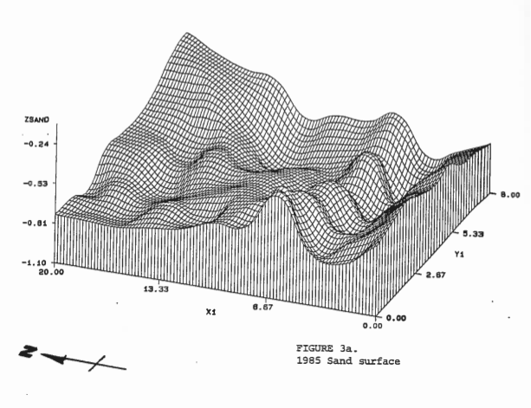

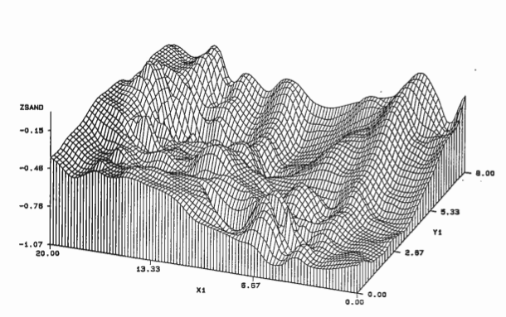

Figure 3b
1987 Sand surface
15

sand level is subject to regular frequent changes of plus or minus 5-10 centimetres. These occur in conjunction with more gradual changes of a greater magnitude. The sand waves move from north to south across the site.
Further work is required before a more complete picture of the sea-bed dynamics that affect the site can be obtained.

4.2 Excavation
A number of leather and rope artefacts were discovered at a depth of approximately 70 centimetres in Trench No 1. Because of the fragile nature of the leather and rope, and because these items were not directly related to the stated aims of the excavation, it was decided to limit the depth of the trench to the level of a deck found immediately above the organic material. During the excavation of Trench No 3 it was found that the internal structure and contents of the wreck were more complete than had been expected. Organic artefacts (leather and rope) were also discovered, in a similar context to those in Trench No 1, in Trench No 3. The presence of fragile organic artefacts in the lower sections of the hull thus precluded complete excavation of both Trenches 1 and 3.
The primary reason for excavation in Trench No 2 was to obtain a profile of the hull at its widest point. Excavation of Trenches 1 and 3 suggested that Trench No 2, like its neighbours, would probably contain extensive internal structure and possibly more fragile organic artefacts. With this probability in mind, it was decided to abandon the excavation of Trench 2 I favour of extending Trench 1
16

forward to include the port side of the bow of the vessel (see Figure 1). This allowed the excavation and examination of a structurally important part of the vessel without increasing the area of the site to be excavated and with no increase in the total time required for the excavation.
The information gained from the excavation enabled more detail to be added to the site plan which was begun during the pre-disturbance survey in 1985 (see Figure 4).

4.3 Construction and Fastening
Due to the difficulties described in section 4.2, little information on the morphology of the hull was obtained. However, during the excavation a series of measurements of the dimensions of the vessel’s timbers and fasteners were taken.
These dimension were tabulated for comparison with dimension, given in Australian Lloyds (1864), Chapman (1768) and Knowles (1822), for vessels of similar size to the Clarence. (see Figure 5)
The results suggest that the Clarence was not built in strict compliance with any particular set of rules. However, with few exceptions, the table indicates that the Clarence’s dimensions vary considerably from those specified. Some of the variation evident may be explained either by erosion of the Clarence timbers by biological and mechanical agents or by incorrect identification of the timbers measured. Misleading measurements were avoided by choosing, where possible, obviously well preserved timbers for measurement. Incorrect identification of timbers was
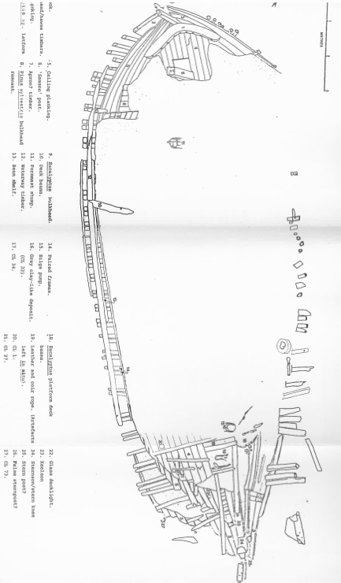
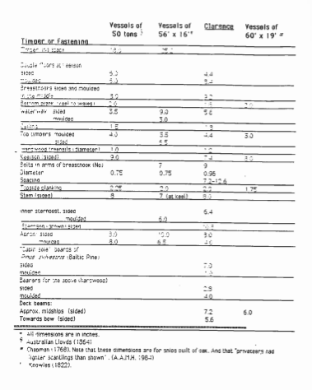

Figure 5

Comparison of scantlings measured from the Clarence.

19

more difficult to control. It is probably the reason for the large discrepancy between the dimensions given in the various scantling tables for the apron timber and those recorded on the site. Structure in this area of the wreck is not well defined and some movement of major timbers has taken place. Consequently, identification of this particular timber as the apron is uncertain.
Some possible reasons for the differences between scantlings are suggested. The use of undersized timbers might have a cost reducing strategy. The saving, however, would have been minimal considering that timber in the Williams River region was abundant, and hence a relatively inexpensive commodity. On the other hand, difficulties in working Australian wood species, particularly hardwoods, led to builders modifying the construction methods they used in their vessels (Fry 1987, 70) This understanding of the qualities and characteristics of Australian timbers may have led to the discovery that ‘standard’ scantlings could be reduced from those specified in the various rules without significantly decreasing the strength of the vessel. However, difficulties in working the wood suggest that the resulting timbers would be more massive than specified.

4.3.1 Knees
Close examination of the two deck beams still in position, and of the beam shelf and adjacent timbers gave no indication that hanging or lodging knees had been used to strengthen this area of the hull. Similarly, no knees which could have served this
20

function were found during the excavation. It is concluded that the Clarence was deliberately built without hanging or lodging knees. The literature consulted indicates, without explanation of why, only two cases of vessels built ‘without knees’ (Strachan 1984, 16). This is the major departure from traditional shipbuilding practice noted in the construction of the Clarence. It has major implications for the degree of strength and durability of the vessel. The absence of the knees in this area of the hull would considerably weaken its resistance to torsional stresses and subject many of the other joints throughout the hull to twisting strain which would no normally occur in ships of more conventional construction. This structural weakness may well have been the reason for the relatively short life of the Clarence. It may also explain the actions of the Clarence’s master, Captain Ainslie, who allegedly orchestrated the stranding of the vessel at Warrnambool in September 1847 in an attempt to collect insurance of about 900 pounds. (Gesner 1984). At that stage the Clarence was only six years old!

4.3.2 Internal structure
The internal structure of the wreck yielded little information which would indicate how the interior of the vessel was fitted out for carrying its particular range of cargoes. The main cargo space of most vessels of this type is in the midships section, Internal

21

features and the type of artefacts uncovered in Trenches 1 and 3, indicate that these areas were used primarily, if not exclusively, for crew accommodation and ship’s equipment storage. Some suggestion of the manner in which these areas were divided was gained from the fragmentary remains of bulkheads which were discovered in both the bow and stern areas of the wreck (See Figure 4).

The most notable feature of the inside of the hull was the extensive use of Baltic Pine (Pinus sylvestris) – Deals of this timber were used for platform decking throughout the vessel. This timber was also used for a number of the bulkheads mentioned above. The Baltic Pine was fastened exclusively with square-shanked iron nails. These have since corroded away leaving square iron-stained holes in the wood.
The use of Baltic Pine in the Clarence seems somewhat anomalous considering the proximity of good supplies of native cedar at the Williams River, NSW. The use of Baltic Pine may be explained by its being cheaper than the local cedar (unlikely). On the other hand it could have been placed in the ship after its original construction, and in a location where the supply of native timber was not as abundant (perhaps when the vessel was refitted after the stranding at Warrnambool).
The lack of detailed historical information on the characteristics, uses and economic value of Australian
22

timbers makes it difficult to determine their significance when they are encountered in shipwrecks. Further study, both archaeological and historical, is necessary to increase our knowledge in this area.

4.3.3 Anti-fouling.
Examination of the outside of the hull near the bow revealed that the vessel was not sheathed with copper alloy. Some small pieces of sheathing material (CL 48) were found. However, the scarcity of this material on the site, and the shape of one of the pieces, suggests that they are most likely to be patches rather than sections of a complete covering of the bottom.
During the examination of the hull a white deposit was noted in, and extracted from, a cleft in the end of a treenail. Analysis revealed that the deposit was composed primarily of calcium carbonate (CaCO3). This suggests that a coating of lime, probably mixed with some other substance (tallow, for example), was applied to the hull in order to provide an anti-fouling surface.

4.3.4 Fasteners
Only two examples of the use of copper alloy fasteners in the Clarence’s hull were noted. Copper alloy bolts were used to fix the breast hook in position and a 4.5 inch (11.25 cm) spikes were used to secure the ends of the outer strakes to the stern post. Elsewhere the planking was secured with treenails interspersed with
23

iron nails/spikes. Iron fasteners were observed in all other applications.

4.3.5 Timber samples
Wood samples were taken from major timbers uncovered during the excavation. The samples (CL 63-68) were sent to the CSIRO for identification by Mr Jugo Ilic. The results of identification are presented below.

The keelson, (CL 63) breasthook, (CL 67) and stern-knee (CL 68), were all identified as Eucalyptus species, possibly Yellow Stringy-bark (Eucalyptus muellerana).
The sample taken from the sternpost (CL 64) was identified as an ash group Eucalypt, possibly messmate (Eucalyptus obliqua).
The platform decking in the bow of the vessel (CL 65 and feature number 4 in Figure 4) was identified as a gum-group Eucalypt, possibly tallow-wood (Eucalyptus microcorys). The apron timber (CL 66, feature No 7 in Figure 4) was also identified as a gun-group Eucalypt. A reddish tinge in the wood suggested that it might be Red Gum (Eucalyptus camaldulensis).

4.4 Artefacts
A catalogue of the artefacts raised from the excavation is presented in Appendix 2. Two artefacts have proved to be of particular interest. One was a pair of pulley sheaves (CL 73) which were raised from Trench 3. They bear a broad arrow
24

stamped into the wood and also into the coak. During 1841 (the year the Clarence was built) HMS Fantome was broken up in New South Wales (MacKenzie 1974,149). It is possible that the sheaves found on the Clarence were purchased second-hand from the Admiralty at a sale of condemned stores.
The second artifact of interest was a sample of the fibre from the rope which was uncovered in Trench 3 (CL 62). Analysis indicated that this was coir (coconut fibre). The knowledge that coir rope was probably a common import from the pacific islands (Bach 1982,75), prompted a search of Jones (1986) to determine if the Clarence itself had been involved in the South Seas trade. The search revealed that in the period between September 1842 and May 1844 a vessel called the Clarence made several voyages to destinations including Treasury Island (in the Solomons) and the Bay of Islands (New Zealand). The major return Cargo for these trips was listed as barrels of oil. It is not absolutely certain that the Clarence mentioned in Jones is the one that is the subject of this report. No details of the tonnage or rig are given in his work. However, the fact that this vessel’s movements are recorded by Jones only between September 1842 and May 1844 is a strong indication that it is the same vessel. Gesner, in his 1984 report, is unable to account for the movements of the Clarence between March 1842 and July 1844. It would thus appear that the finding of coir on the wreck has provided clues about a previously unknown aspect of the vessel’s history which requires further research.
25

4.5 Analysis of artefacts and samples
During the excavation of the Clarence several artefacts were raised for identification and analysis. These analyses were conducted by V.A.S conservator, Margaret Baron, and are the subject of a comprehensive report which is currently in preparation. Appendix 2 presents the results of the artefact analyses.

The numbers and descriptions assigned to the artefacts are listed below. More complete information about the artefacts raised from the site can be found in Appendix 3

CL32 | Grey mud sample.
CL51 | Unidentified, possibly caulking.
CL62 | Cordage sample for identification.
CL75 | Caulking from treenail.
CL30 | Small non-ferrous fastener.
CL44 | Non-ferrous fastener embedded in wood.
CL46 | Non-ferrous fastener, tack?
CL33 | Copper alloy sheeting, possibly sheathing.

4.6 Conclusions
Limited use of copper alloy fasteners, lack of copper alloy sheathing and the discovery of a second-hand pulley in the Clarence all lend weight to the hypothesis that at the time of the vessel’s construction there was a shortage of basic ship’ chandlery items. However, Bach (1982) has shown that in the period between 1822 and 1840 there was a growth in the
26

industries of shipbuilding, provisioning and ships’ chandlery. This suggests that the shortages of items of ships’
chandlery, copper alloy and timber were not as acute as examination of the remains of the Clarence might suggest.
In addition to this the variation in timber dimensions on the Clarence and the omission of hanging and lodging knees from its structure cannot be satisfactorily explained by shortages of materials alone. A more likely explanation is that the dimensional variation and the omission of the knees was a deliberate ploy to keep the cost of the vessel as low as possible. This explanation can also be applied to the scarcity of copper alloy in the vessel and to the presence of second-hand equipment on the wreck.

Excavation has provided strong evidence to suggest that the Clarence was of sub-standard construction. This was most likely to have been a result of either the owner’s or builder’s desire to produce a vessel at the lowest possible cost. The long-term results of this desire are evident in Gesner’s (1984) history of the vessel: Most notable of these were its relatively short life and its quick wrecking after going aground in 1841.
The knowledge gained from the excavation suggests that future work in the investigation of the Australian shipbuilding theme raises the question of whether the cheap construction of the Clarence is the exception or the rule in early Australian shipbuilding.

27

5.0 FUTURE MANAGEMENT AND RESEARCH
5.1 Management
5.1.1 Site security
During the past three years there has been no evidence of disturbance to the site by divers. However, the area around the site is a popular one for fishing and a result, the site is occasionally damaged by the anchors of fishing boats.
The ‘Protected Zone’ sign does not appear to be doing its job. During the excavation fieldwork several fisherman in small boats were asked to leave the protected area. On one occasion an anchor was discovered to have been dragged through the site dislodging the survey grid and safety lines. Surface marker buoys left on the site overnight were frequently stolen.
During the excavation four factors contributing to breaches of the protected zone were identified:
- Perception on the part of fisherman that the site is not policed and that illegal entry is not likely to result in prosecution.
- Inability of fisherman to read the sign. Many of the fishermen are Greek or Italian and are not fluent enough in English to understand the sign.
- The lettering on the sign is too small to be read from the outside the protected area. Thus in order to read the sign one must break the law!
- Fishermen find it difficult to estimate their distance from the pile. The most frequent
28

explanation for breaches of the protected zone was that the offender ‘thought I was far enough away’.
Regular surveillance and enforcement visits to the site by V.A.S staff might gradually increase awareness of the legislation and also help to identify deliberate breaches of the protected zone. These visits would help to increase the security of the site. These visits should be combined with a programme of education of the local fishermen designed to make them aware of the importance of the site, and of the penalties for damaging it.
Multi-lingual signs placed at Queenscliff and St. Leonards boat ramps would also assist in increasing awareness of the site.

5.1.2 Sand Level monitoring
A twelve-month programme of sand-level monitoring at the wreck-site is recommended. This should be aimed, firstly, at determining the success of the backfilling operation and, secondly, at the quantifying seasonal variability of sand levels. The information acquired from this programme would form a valuable tool for future evaluation of sustainability of the site.

In order to speed up the recording of the sand levels it is recommended that a series of reference stakes be driven into the sea-bed at selected locations. Sand levels could then be measured directly from the stakes.
29

5.1.3 Artefact monitoring
Monitoring the dissolved oxygen content in the sediments of the site should be conducted on a regular basis. This would provide an induction of the conservation environment of the artefacts.

5.1.4 Air probing
No further air probing should be conducted on this site. Similarly, serious consideration should be given to abandoning the use of this method of probing on other wreck sites until the effects on buried archaeological material, of injecting air into wreck-sites, are quantified.

5.1.5 Public access and interpretation
If the monitoring programme confirms the success of the backfilling and if the site is found to remain in a stable state throughout the year, consideration should be given to opening the site to the public. A permit system similar to that used in controlling access to the William Salthouse site is suggested. Uncontrolled public access is not recommended because of the fragile nature of the exposed timbers of the site which are particularly vulnerable. They could be exposed to the danger of having anchors dragged through them or of being accidentally damaged by careless divers. The stability of the sea-bed is also fragile and allowing

30

uncontrolled access would increase the risk of damage, by erosion, to an unacceptable level.

Interpretative material for the site should be available before the site is opened to divers. At the minimum this material should include a waterproofed, labeled site plan, detailed description of the site and a statement of why the site is an important part of Australia’s heritage. Consideration might be given to including the site in the ‘Wreck Trail’ project now under way in this state.

5.2 Research.
5.2.1 Sampling
This work has demonstrated that the simple sampling process would yield much useful information about Australian shipbuilding. Consequently, future research on this topic would be greatly assisted by the development of a standardized system for recording dimensions and wood types used in a range of ship’s timbers. Such a system would allow rapid gathering of data from a wide range of sites.

5.2.2 Shoddy construction – the exception or the rule?
Investigation of the Clarence has shown that it was built in what appears to be a shoddy manner. Future research into Australian-built vessels could be aimed at determining if the type of construction used in the

31

Clarence was the exception or the rule for early Australian shipbuilding.

6.0 RECOMMENDATIONS
6.1 Management recommendations

6.1.1 The frequency of surveillance and enforcement trips to the site by the MAU should be increased.
6.1.2 A Twelve-month programme of sand level monitoring on the site should be undertaken in order to determine the stability of the site and the seasonal variability of the sand levels.
6.1.3 A set of reference stakes should be positioned on the site in order to simplify the recording of sand levels for 6.1.2.
6.1.4 Monitoring of dissolved oxygen content in the sediments of the site should be conducted on a regular basis.
6.1.5 No further air probing should be conducted on this site until the effects of injecting air into sites are better understood.
6.1.6 Multi-lingual leaflets should be prepared for distribution to all those found near the site during surveillance trips.
6.1.7 Multi-lingual signs giving details of the protected zone should be placed in conspicuous positions near the Queenscliff and St Leonards boat ramps.

32

6.1.8 The size of the ‘Protected Zone’ sign should be increased to ensure that it is legible from outside the protected area.
6.1.9 If the site can be shown to have returned to a stable state, a permit system similar to that used for the William Salthouse, should be established. This would provide access to the site by divers.
6.1.10 Interpretative material, including waterproofed site- plans and notes on the features of the wreck should be made available to visitors on the site. This material should be in place before the site is opened to the public.

6.2 Research recommendations

6.2.1 Future research should, at least, address the question: ‘Was the method of construction used in the Clarence the exception or the rule?’

6.2.2 The monitoring of sand levels on the site has the potential to provide previously unavailable information on the movement of sediment on shipwreck sites within Port Phillip Bay. Similarly, the measurement of dissolved oxygen levels on the site will also provide data which will add to the knowledge of how artefacts are preserved in shipwreck sites. It is recommended that the results of future monitoring of the site are published or otherwise made available to other researchers.
33

7.0 REFERENCES

Bach, J. 1982. A maritime history of Australia. Pan Books, Sydney Australia.

Chapman, 1786. Architectura navalis mercatoria and a treatise on shipbuilding (extract). in The Australian Association For Maritime History Newsletter No 20, October 1984

Fry, P. 1987. Bluewater Australians. The Australian experience in ocean sailing. ABC Enterprises (for the Australian Broadcasting Corporation). Sydney, Australia.

Gesner, P. 1984. Report to the Victoria Archaeological Survey on historical research of the Clarence. Unpublished V.A.S. internal working document.

Hainsworth, D.R 1971. The Sydney traders: Simeon Lord and his contemporaries, 1788-1812. Sydney.

Harvey, P. 1986. A pre-disturbance survey of the shipwreck Clarence in Port Phillip. Unpublished V.A.S. internal working document.

Jeans, D. N. 1974. Shipbuilding in nineteenth-century New South Wales. Journal of the Royal Australian Historical Society. 60(3): 156-69.
34

Jones, A.G.E. 1986. Ships employed in the South Seas trade 1775-1861 (parts I and II) and register general of shipping and seamen transcripts of registers of shipping 1787-1862 (part III). Roebuck Society Publication No 36. Canberra.

Knowles, John. 1882. The elements and practice of naval architecture; or, a treatise on shipbuilding theoretical and practical on the best principles established in Great Britain. W. Simpkin and R. Marshall, London.

Lloyds, 1864. Rules and regulations, with registration tables applicable to the varieties of colonial timbers used in shipbuilding, scale of fees etc. [Australian Lloyds]. Melbourne.

MacKenzie, M. E. 1974. Shipwrecks and more shipwrecks. Fourth edition. MacKenzie, Portland Victoria.

Strachan, S. M. 1984. Indian and Southeast Asian shipbuilding for the European market: a survey 1790- 1815. Bulletin of the Australian Institute for Maritime Archaeology. 10(2):13-16.

35

APPENDIX 1. SAND PROFILING. Raw data from 1985 and 1987 field seasons.

36

CLARENCE SAND PROFILING DATA COLLECTED IN 1985 DURING THE
PRE-DISTURBANCE SURVEY.

NORTHINGS  (X1 VALUES)  SW corner = 0.0 | EASTINGS  (Y1 VALUES)  SW corner = 0.0 | Distance below  site datum of  sand surface.
0.0 | 0.00 | 0.60
0.0 | 1.00 | 0.55
0.0 | 2.00 | 0.51
0.0 | 3.00 | 0.57
0.0 | 4.00 | 0.61
0.0 | 5.00 | 0.57
0.0 | 6.00 | 0.67
0.0 | 7.00 | 0.69
0.0 | 8.00 | 0.72
2.0 | 0.00 | 0.77
2.0 | 1.00 | 0.70
2.0 | 2.00 | 0.71
2.0 | 3.00 | 0.71
2.0 | 4.00 | 0.74
2.0 | 5.00 | 0.74
2.0 | 6.00 | 0.81
2.0 | 7.00 | 0.83
2.0 | 8.00 | 0.83
4.0 | 0.00 | 0.73
4.0 | 1.00 | 0.80
4.0 | 2.00 | 0.81
4.0 | 3.00 | 0.90
4.0 | 4.00 | 0.96
4.0 | 5.00 | 0.98
4.0 | 6.00 | 1.07
4.0 | 7.00 | 1.01
4.0 | 8.00 | 0.90
6.0 | 0.00 | 0.37
6.0 | 1.00 | 0.50
6.0 | 2.00 | 0.57
6.0 | 3.00 | 0.63
6.0 | 4.00 | 0.72
6.0 | 5.00 | 0.83
6.0 | 6.00 | 0.70
6.0 | 7.00 | 0.77
6.0 | 8.00 | 0.62
8.0 | 0.00 | 0.62
8.0 | 2.00 | 0.65
8.0 | 3.00 | 0.74
8.0 | 4.00 | 0.84
8.0 | 5.00 | 0.88
8.0 | 6.00 | 0.90
8.0 | 7.00 | 0.82
8.0 | 8.00 | 0.70
10.0 | 0.00 | 0.63
10.0 | 2.00 | 0.63
10.0 | 3.00 | 0.66
10.0 | 4.00 | 0.71
10.0 | 5.00 | 0.79
10.0 | 6.00 | -

37

CLARENCE SAND PROFILING DATA COLLECTED IN 1985 DURING THE
PRE-DISTURBANCE SURVEY.

NORTHINGS  (X1 VALUES)  SW corner = 0.0 | EASTINGS  (Y1 VALUES)  SW corner = 0.0 | Distance below  site datum of  sand surface.
10.0 | 7.00 | 0.86
10.0 | 8.00 | 0.70
12.0 | 0.00 | 0.71
12.0 | 1.00 | 0.76
12.0 | 2.00 | 0.68
12.0 | 3.00 | 0.71
12.0 | 4.00 | 0.72
12.0 | 5.00 | 0.82
12.0 | 6.00 | 0.94
12.0 | 7.00 | 0.89
12.0 | 8.00 | 0.75
14.0 | 0.00 | 0.74
14.0 | 1.00 | 0.69
14.0 | 2.00 | 0.75
14.0 | 3.00 | 0.71
14.0 | 4.00 | 0.63
14.0 | 5.00 | 0.67
14.0 | 6.00 | 0.71
14.0 | 7.00 | 0.65
14.0 | 8.00 | 0.50
16.0 | 0.00 | 0.77
16.0 | 1.00 | 0.80
16.0 | 2.00 | 0.80
16.0 | 3.00 | 0.82
16.0 | 4.00 | 1.75
16.0 | 5.00 | 1.70
16.0 | 6.00 | 0.51
16.0 | 7.00 | 0.47
16.0 | 8.00 | 0.45
18.0 | 0.00 | 0.76
18.0 | 1.00 | 0.77
18.0 | 2.00 | 0.70
18.0 | 3.00 | 0.65
18.0 | 4.00 | 0.63
18.0 | 5.00 | 0.63
18.0 | 6.00 | 0.50
18.0 | 7.00 | 0.35
18.0 | 8.00 | 0.36
20.0 | 0.00 | 0.75
20.0 | 1.00 | 0.74
20.0 | 2.00 | 0.79
20.0 | 3.00 | 0.60
20.0 | 4.00 | 0.59
20.0 | 5.00 | 0.57
20.0 | 6.00 | 0.48
20.0 | 7.00 | 0.32
20.0 | 8.00 | 0.24
0.0 | 0.00 | 0.00

38

CLARENCE SAND PROFILING DATA COLLECTED IN 1987 DURING THE
EXCAVATION OF THE SITE.

NORTHINGS  (X1 VALUES)  SW corner = 0.0 | EASTINGS  (Y1 VALUES)  SW corner = 0.0 | Distance below  site datum of  sand surface.
3.0 | 0.00 | 0.92
3.0 | 0.50 | 0.92
17.0 | 0.00 | 0.43
17.0 | 0.50 | 0.46
17.0 | 1.00 | 0.48
17.0 | 1.50 | 0.50
17.0 | 2.00 | 0.49
17.0 | 2.50 | 0.51
17.0 | 3.00 | 0.56
17.0 | 3.50 | 0.54
17.0 | 4.27 | 0.54
17.0 | 4.68 | 0.78
17.0 | 4.75 | 0.83
17.0 | 4.82 | 0.83
17.0 | 5.36 | 0.82
17.0 | 5.82 | 0.63
17.0 | 5.84 | 0.64
17.0 | 6.00 | 0.54
17.0 | 7.00 | 0.38
17.0 | 7.50 | 0.32
17.0 | 8.00 | 0.31
2.0 | 0.00 | 0.92
2.0 | 0.50 | 0.91
2.0 | 1.00 | 0.93
2.0 | 1.50 | 0.95
2.0 | 2.00 | 0.95
2.0 | 2.50 | 0.96
2.0 | 3.00 | 0.98
2.0 | 3.40 | 0.96
2.0 | 4.00 | 1.00
2.0 | 4.50 | 0.92
2.0 | 5.00 | 0.90
2.0 | 5.50 | 0.82
2.0 | 6.00 | 0.76
2.0 | 6.50 | 0.70
2.0 | 7.00 | 0.69
2.0 | 7.50 | 0.52
2.0 | 8.00 | 0.43
1.0 | 0.00 | 0.89
1.0 | 0.50 | 0.88
1.0 | 1.00 | 0.90
1.0 | 1.50 | 0.94
1.0 | 2.00 | 0.95
1.0 | 2.50 | 0.99
1.0 | 3.00 | 1.00
1.0 | 4.00 | 1.00
1.0 | 4.50 | -

39

CLARENCE SAND PROFILING DATA COLLECTED IN 1987 DURING THE
EXCAVATION OF THE SITE.

NORTHINGS  (X1 VALUES)  SW corner = 0.0 | EASTINGS  (Y1 VALUES)  SW corner = 0.0 | Distance below  site datum of  sand surface.
1.0 | 6.50 | 0.74
1.0 | 7.00 | 0.67
1.0 | 7.50 | 0.70
1.0 | 8.00 | 0.67
0.0 | 0.00 | 0.85
0.0 | 0.50 | 0.88
0.0 | 1.00 | 0.95
0.0 | 1.50 | 0.97
0.0 | 2.00 | 0.99
0.0 | 2.50 | 0.96
0.0 | 3.00 | 0.98
0.0 | 3.50 | 1.00
0.0 | 4.00 | 0.96
0.0 | 4.50 | 0.90
0.0 | 5.00 | 0.84
0.0 | 5.50 | 0.79
0.0 | 6.00 | 0.71
0.0 | 6.50 | 0.64
0.0 | 7.00 | 0.63
0.0 | 7.50 | 0.60
0.0 | 8.00 | 0.42
15.0 | 0.00 | 0.48
15.0 | 0.50 | 0.47
15.0 | 1.00 | 0.52
15.0 | 1.50 | 0.57
15.0 | 2.50 | 0.66
15.0 | 3.00 | 0.69
15.0 | 3.50 | 0.77
15.0 | 4.00 | 0.83
15.0 | 5.30 | 1.06
15.0 | 5.50 | 1.03
15.0 | 7.00 | 0.77
15.0 | 7.50 | 0.67
15.0 | 8.00 | 0.63
4.0 | 0.00 | 0.87
4.0 | 0.50 | 0.83
4.0 | 1.28 | 0.91
4.0 | 1.40 | 0.87
4.0 | 1.79 | 0.88
4.0 | 1.89 | 0.80
4.0 | 1.90 | 0.87
4.0 | 2.50 | 0.85
4.0 | 3.00 | 0.87
4.0 | 3.50 | 0.81
4.0 | 4.00 | 0.76
4.0 | 4.50 | 0.74
4.0 | 5.00 | 0.69
4.0 | 5.50 | 0.62
4.0 | 6.00 | 0.53

40

CLARENCE SAND PROFILING DATA COLLECTED IN 1987 DURING THE
EXCAVATION OF THE SITE.

NORTHINGS  (X1 VALUES)  SW corner = 0.0 | EASTINGS  (Y1 VALUES)  SW corner = 0.0 | Distance below  site datum of  sand surface.
4.0 | 7.00 | 0.41
4.0 | 7.50 | 0.39
4.0 | 8.00 | 0.39
5.0 | 8.00 | 0.52
5.0 | 7.50 | 0.55
5.0 | 7.00 | 0.57
5.0 | .50 | 0.61
5.0 | 6.00 | 0.63
5.0 | 5.50 | 0.69
5.0 | 5.00 | 0.75
5.0 | 4.50 | 0.77
5.0 | 4.00 | 0.85
5.0 | 3.50 | 0.93
5.0 | 3.00 | 0.96
5.0 | 2.50 | 0.96
5.0 | 2.00 | 0.85
5.0 | 1.50 | 0.96
5.0 | 0.90 | 0.87
5.0 | 0.50 | 0.93
5.0 | 0.00 | 0.95
6.0 | 0.00 | 0.91
6.0 | 0.50 | 0.69
6.0 | 1.00 | 0.80
6.0 | 1.50 | 0.55
6.0 | 2.00 | 0.83
6.0 | 1.16 | 0.15
6.0 | 1.45 | 0.80
6.0 | 2.61 | 0.80
6.0 | 2.81 | 0.79
6.0 | 3.00 | 0.78
6.0 | 3.50 | 0.81
6.0 | 4.00 | 0.85
6.0 | 3.76 | 0.89
6.0 | 4.50 | 0.73
6.0 | 5.00 | 0.68
6.0 | 5.50 | 0.65
6.0 | 5.81 | 0.66
6.0 | 6.00 | 0.65
6.0 | 6.50 | 0.66
6.0 | 7.00 | 0.67
6.0 | 7.50 | 0.54
6.0 | 7.91 | 0.51
8.0 | 0.00 | 0.79
8.0 | 0.50 | 0.80
8.0 | 1.29 | 0.78
8.0 | 1.50 | 0.70
8.0 | 2.00 | 0.74
8.0 | 2.50 | -

41

CLARENCE SAND PROFILING DATA COLLECTED IN 1987 DURING THE
EXCAVATION OF THE SITE.

NORTHINGS  (X1 VALUES)  SW corner = 0.0 | EASTINGS  (Y1 VALUES)  SW corner = 0.0 | Distance below  site datum of  sand surface.
8.0 | 4.00 | 0.84
8.0 | 4.50 | 0.82
8.0 | 5.00 | 0.82
8.0 | 5.50 | 0.83
8.0 | 6.00 | 0.87
8.0 | 6.50 | 0.86
8.0 | 7.00 | 0.81
8.0 | 7.50 | 0.75
8.0 | 8.00 | 0.64
10.0 | 0.00 | 0.72
10.0 | 0.28 | 0.72
10.0 | 0.50 | 0.68
10.0 | 2.50 | 0.66
10.0 | 3.00 | 0.69
10.0 | 3.50 | 0.72
10.0 | 4.00 | 0.82
10.0 | 4.50 | 0.89
10.0 | 5.00 | 1.00
10.0 | 5.50 | 0.94
10.0 | 6.00 | 0.96
10.0 | 6.50 | 0.96
10.0 | 7.00 | 0.93
10.0 | 7.50 | 0.82
10.0 | 8.00 | 0.68
12.0 | 0.00 | 0.54
12.0 | 0.51 | 0.55
12.0 | 1.00 | 0.58
12.0 | 1.50 | 0.58
12.0 | 1.72 | 0.59
12.0 | 2.02 | 0.65
12.0 | 2.52 | 0.45
12.0 | 3.00 | 0.49
12.0 | 3.50 | 0.58
12.0 | 4.00 | 0.69
12.0 | 4.50 | 0.63
12.0 | 5.00 | 0.72
12.0 | 5.50 | 0.76
12.0 | 6.00 | 0.77
12.0 | 5.92 | 0.74
12.0 | 6.50 | 0.72
12.0 | 7.00 | 0.66
12.0 | 7.50 | 0.54
12.0 | 8.00 | 0.50
14.0 | 0.00 | 0.46
14.0 | 0.50 | 0.48
14.0 | 1.00 | 0.47
14.0 | 1.50 | 0.56
14.0 | 2.00 | 0.62
14.0 | 2.50 | 0.62

42

CLARENCE SAND PROFILING DATA COLLECTED IN 1987 DURING THE
EXCAVATION OF THE SITE.

NORTHINGS  (X1 VALUES)  SW corner = 0.0 | EASTINGS  (Y1 VALUES)  SW corner = 0.0 | Distance below  site datum of  sand surface.
14.0 | 3.50 | 0.70
14.0 | 4.00 | 0.73
14.0 | 4.50 | 0.75
14.0 | 5.00 | 0.82
14.0 | 5.50 | 0.92
14.0 | 6.00 | 0.92
14.0 | 6.50 | 0.81
14.0 | 7.00 | 0.74
14.0 | 7.50 | 0.69
14.0 | 8.00 | 0.59
15.0 | 0.00 | 0.44
15.0 | 0.50 | 0.42
15.0 | 1.00 | 0.48
15.0 | 1.50 | 0.54
15.0 | 2.00 | 0.62
15.0 | 2.50 | 0.52
15.0 | 3.00 | 0.65
15.0 | 3.50 | 0.64
15.0 | 4.00 | 0.75
15.0 | 4.50 | 0.74
15.0 | 5.00 | 0.82
15.0 | 5.50 | 0.89
15.0 | 6.00 | 0.84
15.0 | 6.50 | 0.67
15.0 | 7.00 | 0.61
15.0 | 7.50 | 0.54
15.0 | 8.00 | 0.50
16.0 | 3.00 | 0.67
16.0 | 3.50 | 0.63
16.0 | 5.50 | 0.77
18.0 | 0.00 | 0.49
18.0 | 0.50 | 0.50
18.0 | 1.50 | 0.49
18.0 | 2.00 | 0.51
18.0 | 2.50 | 0.42
18.0 | 3.00 | 0.39
18.0 | 3.50 | 0.40
18.0 | 4.00 | 0.40
18.0 | 4.50 | 0.35
18.0 | 5.00 | 0.37
18.0 | 5.50 | 0.39
18.0 | 6.00 | 0.41
18.0 | 6.50 | 0.36
18.0 | 7.00 | 0.37
18.0 | 7.50 | 0.39
18.0 | 8.00 | 0.39
20.0 | 0.00 | 0.37
20.0 | 0.50 | 0.37
20.0 | 1.00 | -

43

CLARENCE SAND PROFILING DATA COLLECTED IN 1987 DURING THE
EXCAVATION OF THE SITE.

NORTHINGS  (X1 VALUES)  SW corner = 0.0 | EASTINGS  (Y1 VALUES)  SW corner = 0.0 | Distance below  site datum of  sand surface.
20.0 | 2.00 | 0.30
20.0 | 2.50 | 0.25
20.0 | 3.00 | 0.22
20.0 | 3.50 | 0.23
20.0 | 4.00 | 0.23
20.0 | 4.50 | 0.25
20.0 | 5.00 | 0.31
20.0 | 5.50 | 0.31
20.0 | 6.00 | 0.31
20.0 | 6.50 | 0.27
20.0 | 7.00 | 0.28
20.0 | 7.50 | 0.29
20.0 | 8.00 | 0.34
18.0 | 0.00 | 0.47
17.9 | 0.49 | 0.49
17.8 | 0.99 | 0.48
17.7 | 1.48 | 0.50
17.6 | 1.98 | 0.50
17.6 | 2.47 | 0.46
17.5 | 2.97 | 0.49
17.4 | 3.47 | 0.41
16.0 | 3.96 | 0.59
16.0 | 0.00 | 0.46
16.0 | 0.50 | 0.49
16.0 | 1.00 | 0.51
16.0 | 1.50 | 0.55
16.0 | 2.00 | 0.60
16.0 | 4.00 | 0.66
16.0 | 4.49 | 0.71
16.0 | 4.92 | 0.75
16.0 | 5.80 | 1.03
16.0 | 6.00 | 0.86
16.0 | 6.45 | 0.72
16.0 | 6.60 | 0.65
16.0 | 7.08 | 0.71
16.0 | 7.50 | 0.60
16.0 | 8.00 | 0.58
17.0 | 6.34 | 0.00
0.0 | 0.00 | 0.00
*** Total ***
2966.4

44

APPENDIX 2. ANALYSIS OF ARTEFACTS

This appendix presents the results of analysis of the artifact material refered to in section 4.5 of this report. The methods used in the analyses are also outlined.

METHODS
CL32, CL51
Both of these samples were ground to a fine powder and analysed by X-Ray diffraction using a Siemens D501 Diffractoeter.

CL62
This sample of cordage was teased out and individual fibres examined under a microscope.

CL75
This black substance was thought to be pitch or tar. It was heated over a water bath with hexane in order to extract any organic matter. The hexane extract was then applied to a Potassium bromide disk and analyses using Pye Unicam SP3-300 infra-red spectrophotometer.

45

CL30. 44, 46, 33.
A sample of each item was obtained using a jewelers saw. Each sample was polished with wet-dry abrasive paper, diamond paste (of 15ƒm, 6ƒm, 1ƒm and 0.5ƒm grain size) and gamma alumina powder.

Samples were then etched in a solution of the following composition;

Ferric chloride,…………………… .10 g
Concentrated Hydrochloric acid, … 30 ml
Water ……………………………. 120 ml

Etching times of 10-60 seconds were used.

The samples were examined by optical microscopy.
Elemental composition of the samples was determined using a Camscan Series 4 scanning electron microscope, coupled to a Tracor Northern TN5500 Energy Dispersive X-ray Analysis system

46

RESULTS
CL32
The diffraction pattern of the sample was that of a mixture of quartz and feldspars. Traces of illite, heamatite and kaolinite were also detected.

CL51
This substance was identified as calcite (calcium carbonate).

CL62
Comparison of the fibre sample with standard fibres showed it to be coir (coconut fibre).

CL75
The hexane extract was found to contain aliphatic hydrocarbons similar to those found in asphalt and bitumen

CL30, CL44, and CL46)
Each of the fasteners was found to have dendritic microstructure indicating that the fasteners were all cast. There was no evidence of working in the samples examined.

Globular inclusions, indicative of tin and lead, were observed in each of the samples.

47

The sheeting, CL33, was a wrought copper alloy which showed evidence (twinning) of cold working. Some areas of the sample which were adjacent to areas of corrosion on the metal were shown to have copper-rich grain boundaries. Samples of both CL30 and CL46 showed evidence of dezincification

Elemental analysis
The results of the elemental analyses are presented in the table below.
SAMPLE | %Cu | %Zn | %Pb | %Sn | %Fe | %Bi
CL30 | 78.1 | 7.1 | 11.0 | 3.8 | --- | ---
CL44 | 92.4 | 6.6 | tr* | 1.0 | --- | tr*
CL46 | 79.4 | 4.8 | 11.0 | 4.5 | 0.3 | ---
CL33 | 67.0 | 33.0 | --- | --- | --- | ---
*tr = trace <0.1%>

48

APPENDIX 3. CATALOGUE OF ARTEFACTS RAISED DURING THE EXCAVATION OF THE CLARENCE

Part 1 Artefact list
Part 2 Artefact drawings
Part 3 Artefact photographs

49

APPENDIX 3 Part 1. Artefact list.

Note; The last three digits of the registration numbers are the numbers used to refer to artefacts elsewhere in this report. The prefix ‘CL’ is used to identify the Clarence wreck.

CLARENCE 1987 EXCAVATION ARTEFACT LIST

REG NO | DESCRIPTION | MATERIAL | WEIGHT (GM) | F | H | O | UK | SOURCE
12732.001 | COMPASS, HOUSING | METAL, NON-FERROUS, COPPER ALLOY, BRASS? | 0.00 | .T. | .F. | .F. | .F. | TRENCH 3 ANAEROBIC SAND 30CM
12744.022 | BOTTLE AND WINDOW FRAGMENTS 14 PIECES | CERAMIC, GLASS | 0.00 | .F. | .F. | .T. | .F. | TRENCH 3
12732.023 | HANDLE, DRAW OR CUPBOARD | METAL NON-FERROUS COPPER ALLOY, BRASS? | 0.00 | .T. | .F. | .F. | .F. | TRENCH 3 ANAEROBIC SAND
12732.024 | HOOK CUPHOLDER? | METAL NON-FERROUS COPPER ALLOY BRASS? | 0.00 | .T. | .F. | .F. | .F. | TRENCH 3 ANAEROBIC SAND
12786.025 | BOLTS CASTS IN CONCRETION 3 PIECES | CONCRETION | 0.00 | .F. | .T. | .F. | .F. | TRENCH 3
12732.026 | FASTENER TACK CUT-TACK | METAL, NON-FERROUS, COPPER ALLOY BRASS? | 0.16 | .F. | .F. | .T. | .F. | IN SEDIMENT FROM 12732.001
12782.027 | PULLEY SHEAVE | WOOD AND METAL, IRON | 1054.00 | .T. | .F. | .F. | .F. | TRENCH 3 ANAROBIC SAND 40CM
12727.028 | CLAY PIPE, STEM | CERAMIC | 2.36 | .F. | .F. | .T. | .F. | TRENCH 3 INSIDE 12732.001
12729.029 | SHERD INKWELL? | CERAMIC, | 4.48 | .F. | .F. | .T. | .F. | TRENCH 3 INSIDE 12732.001
12738.030 | TIMBER AND FASTENINGS, NAILS? TACKS | METAL NON-FERROUS COPPER? | 153.29 | .F. | .T. | .F. | .F. | TRENCH 1 ANAEROBIC SAND 30CM
12744.031 | BOTTLE AND WINDOW GLASS SHERDS 10 PIECES | CERAMIC, GLASS | 0.00 | .F. | .F. | .T. | .F. | TRENCH 3
12730.032 | GREY MUD, SAMPLE | UNKNOWN | 0.00 | .F. | .F. | .F. | .T. | TRENCH 3 STARBOARD 10CM
12732.033 | UNIDENTIFIED PATCH? | METAL NON-FERROUS COPPER ALLOY | 43.78 | .F. | .F. | .F. | .T. | TRENCH 3 STARBOAORD
12721.034 | CONTAINER SHERDS 13 PIECES | CERAMIC | 0.00 | .F. | .F. | .T. | .F. | TRENCH 3 STARBOARD
12729.035 | SHERD BLUE AND WHITE PATTERN | CERAMIC | 12.86 | .F. | .F. | .T. | .F. | TRENCH 3 ANAEROBIC SAND 30CM
12748.036 | SEDIMENT CONTAINED IN 12732001 | BLACK SEDIMENT CONTAINING SHELL AND ORGANIC | 20.26 | .F. | .F. | .F. | .T. | TRENCH 3 ANAROBIC 30CM
12744.037 | BOTTLE, SHERDS, CASE GIN? 14 PIECES | CERAMIC, GREEN GLASS | 224.68 | .F. | .F. | .T. | .F. | TRENCH 3
12734.038 | WEIGHT | METAL, NON-FERROUS, LEAD | 416.70 | .F. | .F. | .F. | .T. | TRENCH 3
12765.039 | HANDLE, TURNED TIMBER | WOOD | 124.43 | .F. | .F. | .F. | .T. | TRENCH 3
12767.040 | FASTENING, TRUNNEL TREENAIL WOODEN DOWEL 2 PARTS | WOOD | 28.89 | .F. | .T. | .F. | .F. | TRENCH 3
12712.041 | COAL | COAL | 0.00 | .F. | .F. | .F. | .T. | TRENCH 3
12767.042 | TIMBER FRAGMENT | WOOD | 0.00 | .F. | .F. | .F. | .T. | TRENCH 3
12732.043 | FASTENER, NAIL | METAL, NON-FERROUS, COPPER ALLOY, BRASS? | 81.81 | .F. | .T. | .F. | .F. | TRENCH 3 ANAEROBIC SAND
12732.044 | FASTENER, NAIL AND IMBEDDED IN WOOD | METAL NON-FERROUS COPPER ALLOY BRASS? | 287.94 | .F. | .T. | .F. | .F. | TRENCH 3
12732.046 | FASTENERS NAILS, TACKS 2 PIECES | METAL NON-FERROUS COPPER ALLOY COPPER? | 2.36 | .F. | .F. | .F. | .T. | TRENCH 1 PORT SIDE
12734.047 | WEIGHT FISHING? | METAL, NON-FERROUS, LEAD | 208.95 | .F. | .F. | .F. | .T. | TRENCH 1 PORT SIDE 20 CM
12732.048 | SHEATHING FRAGMENTS WITH NAIL HOLES 2 PIECES | METAL NON-FERROUS COPPER ALLOY | 21.15 | .F. | .T. | .F. | .F. | TRENCH 1
12786.049 | FASTENER, NAIL HEAD ONLY CAST IN CONCRETION | IRON CONRECTION | 2.65 | .F. | .T. | .F. | .F. | TRENCH 1
12744.050 | SHEET GLASS 2 PIECES FROM 12732001 COMPASS? | CERAMIC GLASS | 1.30 | .T. | .F. | .F. | .F. | TRENCH 1
12749.051 | UNIDENTIFIED SUBSTANCE, POSS. CAULKING | CALCIUM CARBONATE SEE TREATMENT MEMO | 1.09 | .F. | .F. | .T. | .F. | TRENCH 1 STARBOARD SIDE
12725.052 | BRICK FRAGMENT | CERAMIC, EARTHENWARE | 338.80 | .F. | .F. | .F. | .T. | TRENCH 3
12732.053 | FASTENER, MACHINE SCREW | METAL NON-FERROUS COPPER ALLOY | 7.06 | .T. | .F. | .F. | .F. | TRENCH 3 30CM
12733.054 | LID, HINGED. | METAL, NON-FERROUS, PEWTER | 29.40 | .F. | .F. | .T. | .F. | TRENCH 3
12733.055 | PULLEY SHEAVE AND BEARING | COMPOSITE, IRON AND WOOD | 509.92 | .T. | .F. | .F. | .F. | TRENCH 3
12744.056 | BOTTLE, SHERDS, NECK AND BASE, 2 PIECES | CERAMIC, GLASS, GREEN GLASS | 54.93 | .F. | .F. | .F. | .T. | TRENCH 3
12744.057 | BOTTLE, CASE GIN, SHERDS, 7 PIECES | CERAMIC, GLASS, GREEN GLASS | 0.00 | .F. | .F. | .T. | .F. | TRENCH 3
12744.058 | BOTTLE, CASE GIN, SHERDS 9 PIECES | CERAMIC, GLASS GREEN GLASS | 0.00 | .F. | .F. | .T. | .F. | TRENCH 3
12732.059 | FASTENER, NAIL, TACK | METAL, NON-FERROUS, COPPER ALLOY | 1.35 | .F. | .F. | .T. | .F. | TRENCH 1
12746.060 | UNKNOWN MARKED WITH “VIII” | ORGANIC, ANIMAL MATERIAL, LEATHER | 104.20 | .F. | .F. | .F. | .T. | TRENCH 1 ANAROBIC SEDIMENT
12744.061 | DECKLIGHT 2 PIECES | CERMAIC, GLASS, CLEAR GLASS | 177.05 | .T. | .F. | .F. | .F. | TRENCH 3
12747.062 | TWINE OR ROPE FRAGMENT | ORGANIC, PLANT MATERIAL, COIR. | 0.09 | .F. | .F. | .F. | .T.
12767.063 | SAMPLE FOR IDENTIFICATION | ORGANIC, PLANT MATERIAL, WOOD | 10.19 | .F. | .T. | .F. | .F. | TRENCH 3 KEELSON
12767.064 | SAMPLE FOR IDENTIFICATION | ORGANIC, PLANT MATERIAL, WOOD | 30.14 | .F. | .T. | .F. | .F. | TRENCH 3 STERNPOST
12767.065 | SAMPLE FOR IDENTIFICATION | ORGANIC, PLANT MATERIAL, WOOD | 13.25 | .F. | .F. | .T. | .F. | TRENCH 1 SOLE PLANKING
12767.066 | SAMPLE FOR IDENTIFICATION | ORGANIC, PLANT MATERIAL, WOOD | 14.73 | .F. | .T. | .F. | .F. | TRENCH 1 STEMPOST
12767.067 | SAMPLE FOR IDENTIFICATION | ORGANIC, PLANT MATERIAL, WOOD | 13.60 | .F. | .T. | .F. | .F. | TRENCH 1 BREASTHOOK
12767.068 | SAMPLE FOR IDENTIFICATION | ORGANIC, PLANT MATERIAL, WOOD | 16.25 | .F. | .T. | .F. | .F. | TRENCH 3 STERN-KNEE
12767.690 | SLAG | METAL, FERROUS, IRON CORROSION PRODUCTS? | 85.86 | .F. | .F. | .F. | .T. | TRENCH 1
12712.070 | COAL | COAL | 44.03 | .F. | .F. | .T. | .F. | TRENCH 1
12786.071 | UNKNOWN | IRON CORROSION PRODUCTS AND SEDIMENT | 61.10 | .F. | .F. | .F. | .T. | TRENCH 3
12744.072 | BOTTLE, FRAGMENTS, CASE GIN? 8 PIECES | CERAMIC, GLASS, GREEN GLASS. | 0.00 | .F. | .F. | .T. | .F. | TRENCH 3
12782.073 | PULLEY SHEAVES, FROM A DOUBLE BLOCK? 2 PIECES | IRON AND WOOD AND COPPER ALLOY | 0.00 | .T. | .F. | .F. | .F. | TRENCH 3 STERN, PORT SIDE
12744.074 | BOTTLE, SHERDS 4 PIECES | CERAMIC, GLASS, GREEN GLASS. | 0.00 | .F. | .F. | .T. | .F. | TRENCH 3
12730.075 | CAULKING FROM TRUNNEL/TREENAIL | UNKNOWN | 0.00 | .F. | .F. | .T. | .F. | TRENCH 1 PORT BOW PLANKING
12741.076 | HANDLE, KNIFE | IVORY OR BONE | 16.77 | .F. | .F. | .T. | .F. | TRENCH 1 ANAEROBIC SILT

52

APPENDIX 3 Part 2. Artefact drawings.

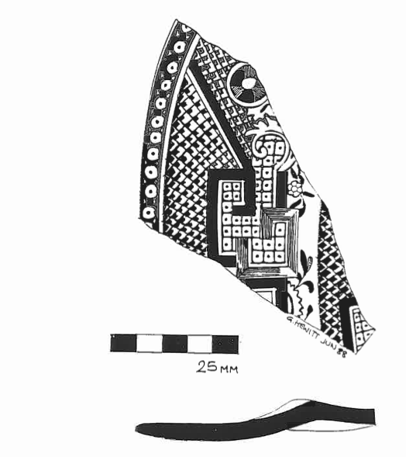
CL 15 Ceramic sherd, blue and white transferware. Drawn by G. Hewitt.

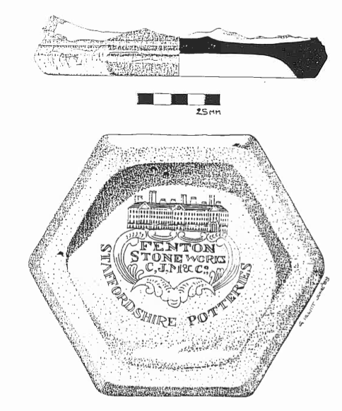

CL 14 Stoneware, base from container of unknown function.
Drawn by G. Hewitt.

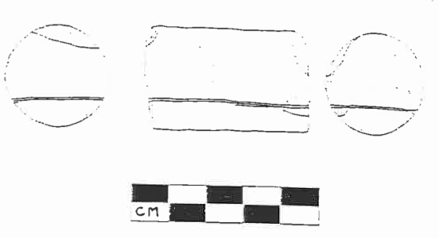

CL 40 Wooden treenail. Drawn by K. Hosty

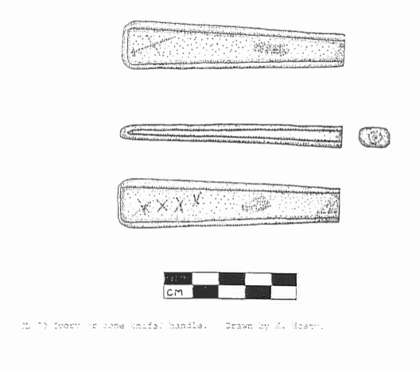

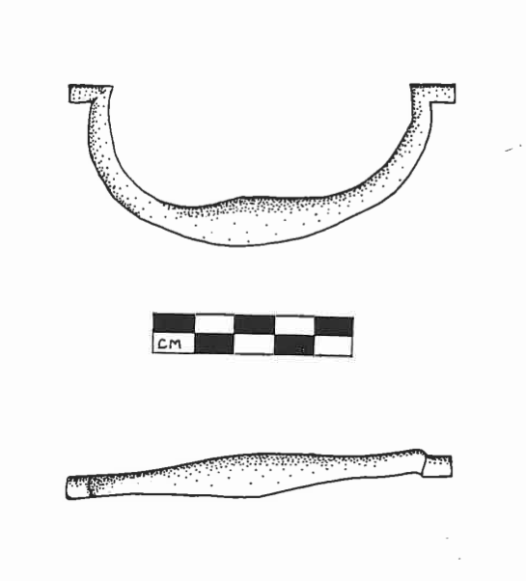
CL 23 Copper alloy handle. Drawn by B. Duncan.

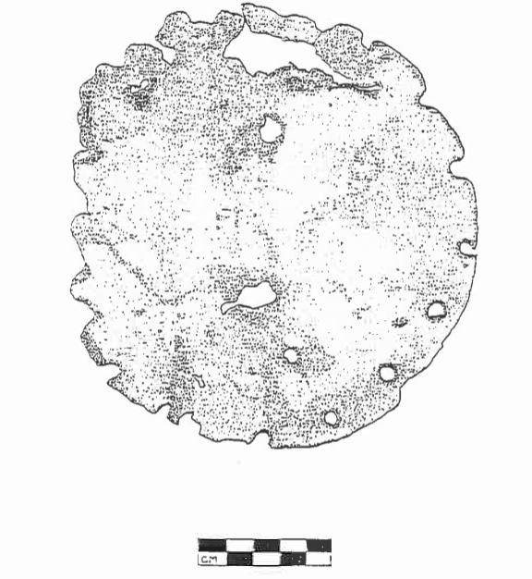

CL 33 Copper alloy sheet. Patch? Drawn by B. Duncan

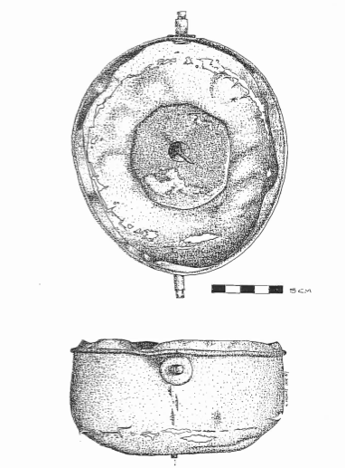

CL 1 Copper alloy compass housing with lead counterweight.
Drawn by G. Hewitt.

APPENDIX 1 Part 3. Artefact photographs.

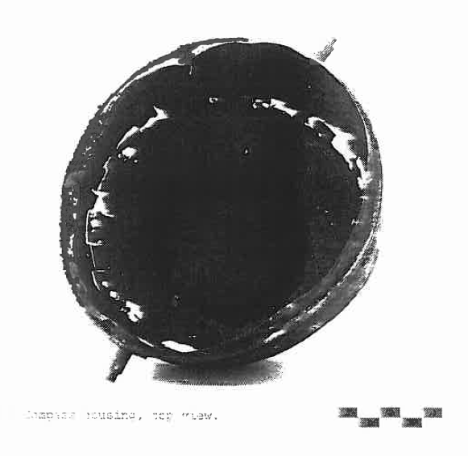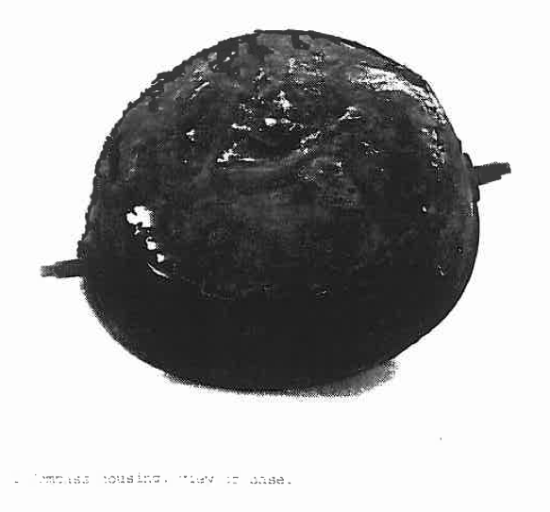
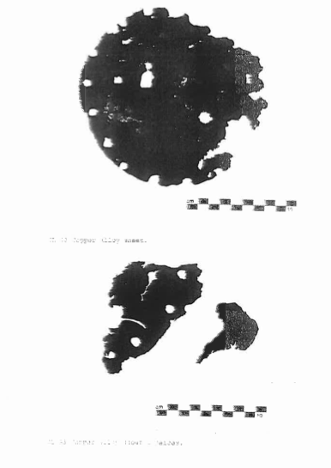

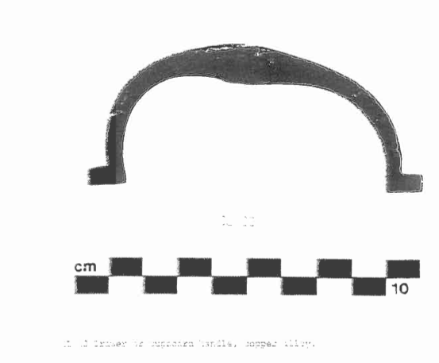
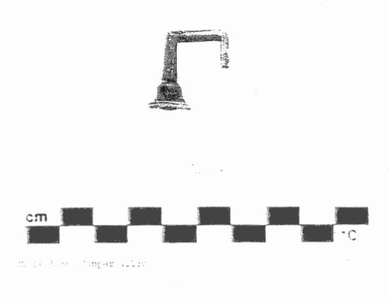

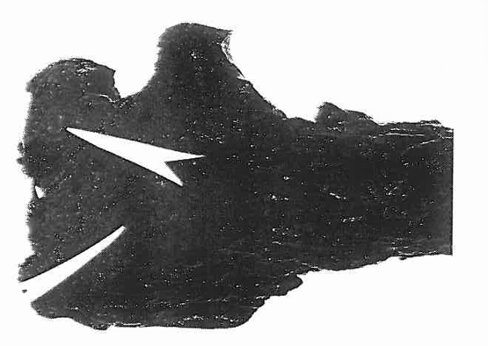
CL 10 Copper alloy fasteners in wood. Arrow is 4cm long.
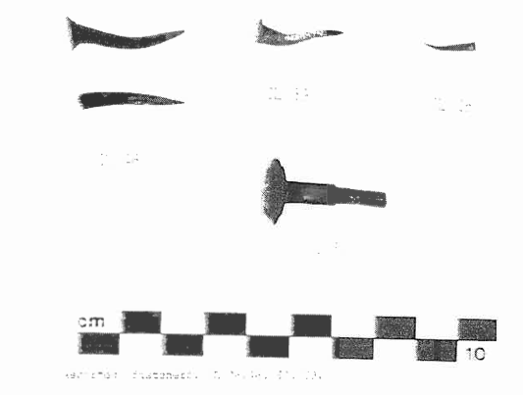
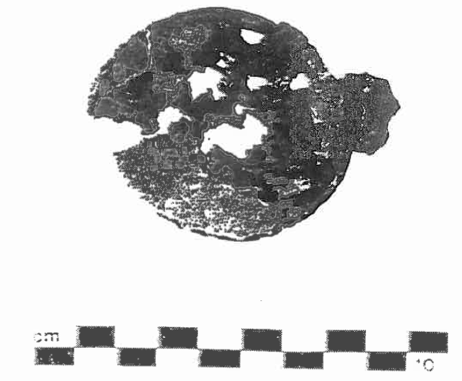

CL 34 Hinged pewter lid.

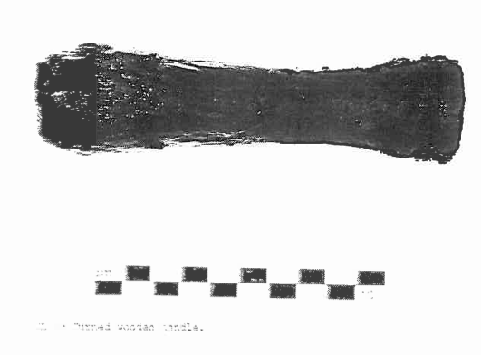
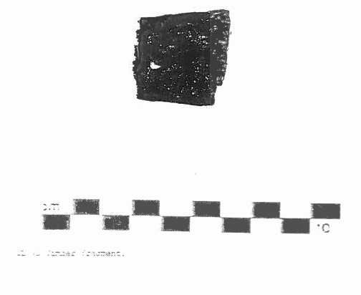

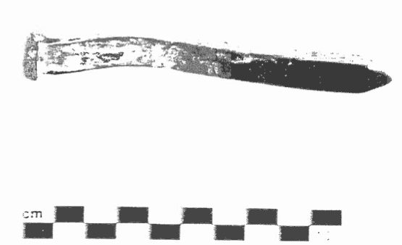

CL 40 Copper alloy fastener.

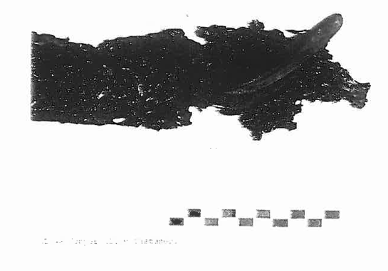

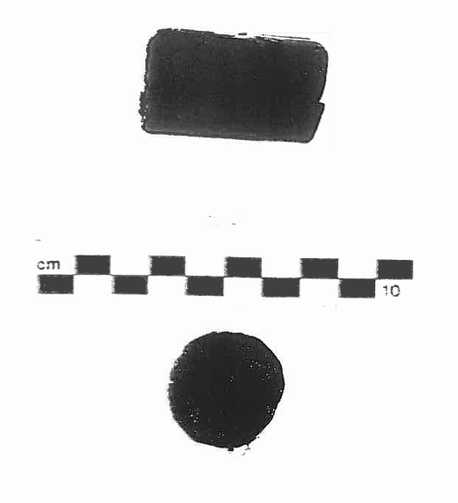

CL 40 Treenail, side and end views.

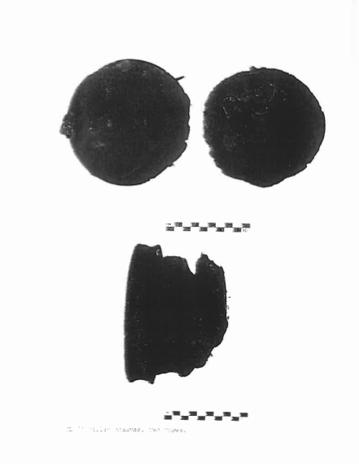

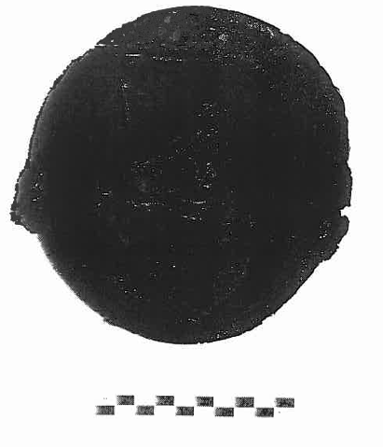
CL ?3 showing ‘broad arrow’ marking.

